[KULBHUSHAN UPADHYAY]

(TOPS TECHNOLOGIES)

22/10/2023

CSS and CSS 3-2

{CSS}

***Module (CSS and CSS 3) -2***

**Q. What are the benefits of using CSS?**

**ANS:**  **Some benefits of CSS**

* The main advantage of CSS is that style is applied consistently across a variety of sites. One instruction can control several areas, which is advantageous.
* Web designers need to use a few lines of programming for every page to improve site speed.
* Faster page speed. More code means slower page speed, and global web standards
* Better user experience. CSS not only makes web pages easy on the eye, it also allows for user-friendly formatting.
* Quicker development time and easy formatting changes Easier to maintain and update. CSS is easy to maintain due to its short maintenance time.
* Consistent design and time-saving Better device compatibility
* Positioning of Design and Elements Greater consistency in design
* Search engine optimization has benefits. More formatting options and faster download times
* Ease of presenting different styles to different viewers

**Q. What are the disadvantages of CSS?**

**ANS: Some Disadvantages of CSS**

* Cross-Browser Issues. One of the major disadvantages of CSS is its cross-browser problem. (Browser compatibility)
* Learning Curve. Although CSS is an easy language to learn, some of its syntax is quite complicated.
* Complex layouts, over specificity,
* CSS, from CSS 1 up to CSS 3, results in confusion among web browsers.
* With CSS, what works with one browser might not always work with another. The web developers need to test for compatibility, running the program across multiple browsers.
* There is a scarcity of security.
* After making the changes, we need to confirm their compatibility if they appear. A similar change affects all browsers.
* The programming language world is complicated for non-developers and beginners. Different levels of CSS, i.e., CSS, CSS 2, and CSS 3, are often quite confusing.

**Q. What is the difference between CSS2 and CSS3?**

**ANS:** The CSS3 version supports more browsers than CSS2.

* Unlike CSS2, which was comprised of a single document, CSS3 has its specifications divided into many individual modules, which makes it a whole lot easier to handle.
* With CSS3, designers can now use special fonts, like those available in Google Fonts and Typecast. Earlier, with CSS2, designers could only use “web-safe fonts” because they were 100% sure to use fonts that would always display the same on every machine.
* While css2 had simple selectors’, css3 calls the components 'a sequence of simple selectors.
* CSS3 introduces several properties with new values and units. It facilitates the styling of backgrounds, borders, boxes, etc. New values and new units were introduced to support all those new properties. For example, angle units deg, grad, rad, and switch, or time units s and ms.
* CSS3 has the capability to split text sections into multiple columns so that they can be read like a newspaper. In CSS2, the developers had difficulty because the standard was not equipped with automatically breaking the text so that it fits within a box.

|  |  |  |
| --- | --- | --- |
| Parameters | CSS2 | CSS3 |
| Compatibility | There is no backward compatibility with CSS2. | There is backward compatibility maintained with CSS 3. |
| Fonts | With CSS2, only web-safe fonts can be used. | With CSS3, special fonts can be used, such as Google Font and others, it also supports web-safe fonts. |
| Border Box Support | NO | YES |
| Selectors | Simple selectors | A sequence of simple selectors |
| Rounded Borders | NO | YES |
| Split Text Feature | NO | YES |
| Grid System and Template Layout | No | YES |
| Styling | Normal | Advance |
| Shadows | NO | YES |
| ANIMATION | No | YES |

**Q. Name a few CSS style components**

**ANS**:  **CSS writing style example.**

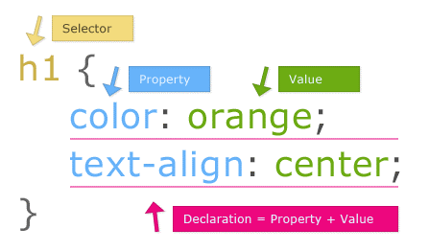

* ***Here are some CSS-style components.***

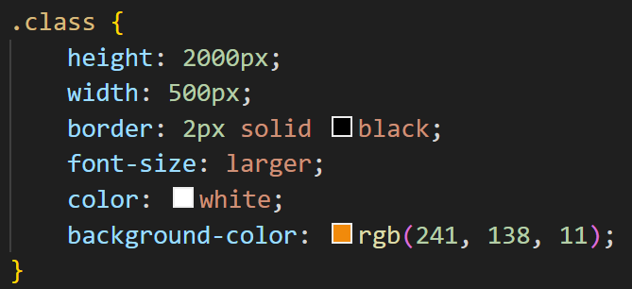

Height: change height.

Width is the change in width of element.

Border: To make a border and manage its thickness and type, and also to change the color of the border.

Color is used for changes in font color.

Background color is used to make a colorful background.

**Q. What do you understand by CSS opacity?**

**ANS**: Opacity is the degree to which the content behind an element is hidden and is the opposite of transparency.

* The CSS opacity property is used to specify the transparency of an element. In a simple word, you can say that it specifies the clarity of the image.
* Values for this property range from 0 to 1. If you set the property to 0, the styled element will be completely transparent.

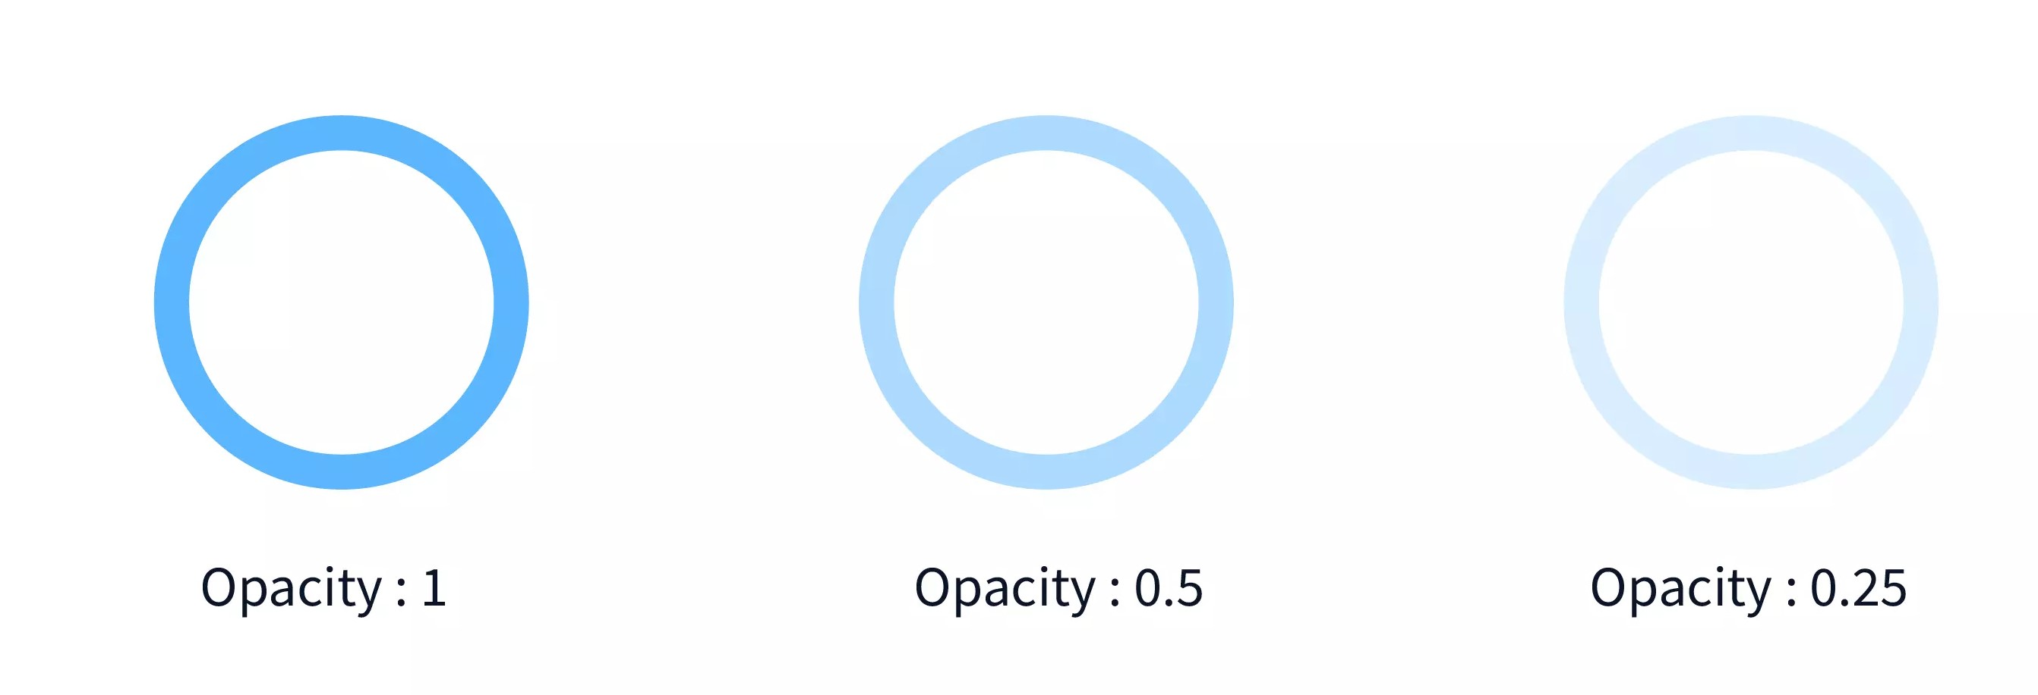

**Q. How can the background color of an element be changed?**

**ANS:** You can change the background color of an HTML and its element with the CSS property background-color: (Color Value);

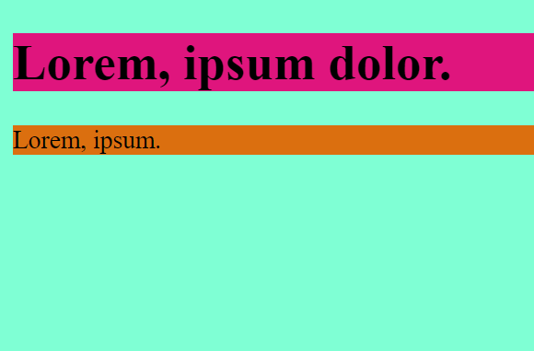

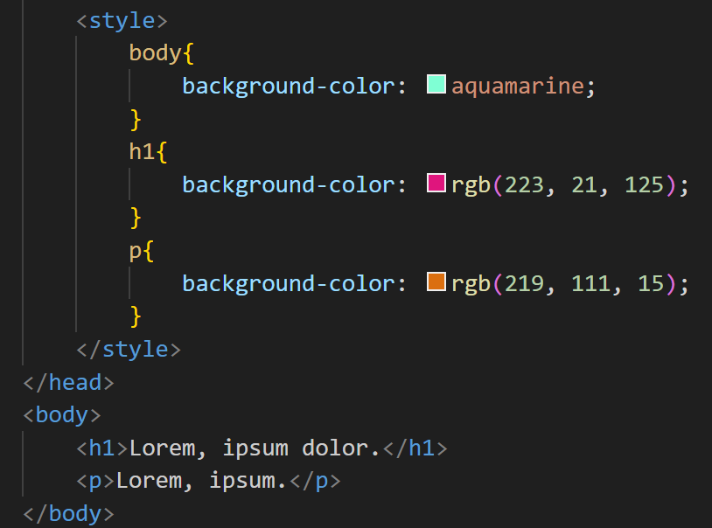

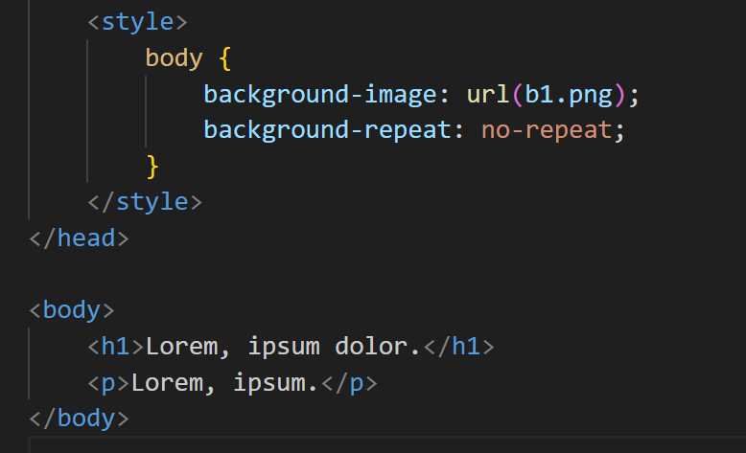**Q. How can image repetition of the backup be controlled?**

**ANS:** To control image repetition in the HTML body with the CSS property

* Background-repeat: no-repeat;

**Q. What is the use of the background-position property?**

**ANS:** Background-position: The background-position property sets the position of a background image on a web page.

* One of the keyword values is top, left, bottom, or right. This specifies an edge against which to place the item.
* 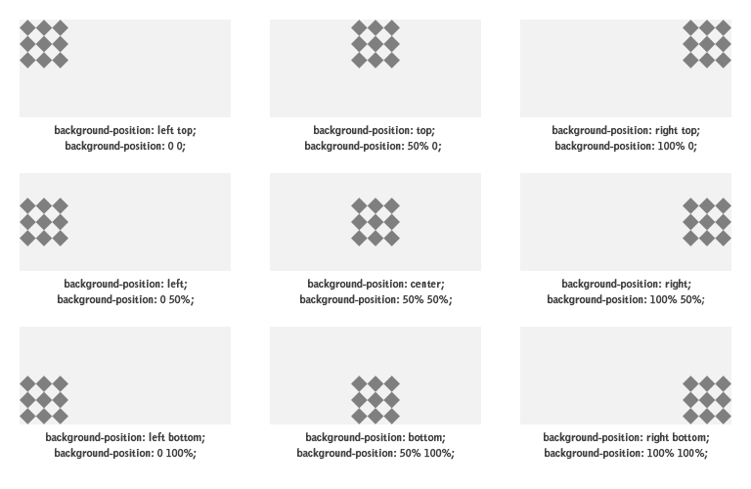A position defines an x/y coordinate to place an item relative to the edges of an element's box. It can be defined using one to four values. If two non-keyword values are used, the first value represents the horizontal position, and the second represents the vertical position.

**Q. Which property controls the image scroll in the background?**

**ANS:** The background-attachment property in CSS is used to specify the kind of attachment of the background image with respect to its container. It can be set to scroll or remain fixed. It can be applied to all HTML elements.

To keep your background image fixed, you have to use the background-attachment property with the value fixed. Syntax: **background-attachment: fixed;**

[Values](https://developer.mozilla.org/en-US/docs/Web/CSS/background-attachment#values)

* [**Fixed**](https://developer.mozilla.org/en-US/docs/Web/CSS/background-attachment#fixed) = The background is fixed relative to the viewport. Even if an element scrolls, the background doesn't move with the element.
* [**Scroll**](https://developer.mozilla.org/en-US/docs/Web/CSS/background-attachment#scroll) = The background is fixed relative to the element itself and does not scroll with its contents.
* [**Local**](https://developer.mozilla.org/en-US/docs/Web/CSS/background-attachment#local) = The background is fixed relative to the element's contents. If the element has scrolling, the background scrolls with the element's contents, and the background painting area and background positioning area are relative to the scrollable area of the element rather than to the border framing them.

**Q. Why should background and color be used as separate properties?**

**ANS:**  Background and color are separate properties because they can be used for different purposes. The background property is used to set the background color or image of an element, while the color property is used to set the text color of that element. These properties can be used together to create a cohesive design, but they can also be used separately to create different effects. For example, you might want to set a background color for an element but leave the text color as the default.

**Examples of background-related properties:**

* background-color: Specifies the background color of an element.
* background-image: Specifies an image to be used as the background of an element.
* background-repeat: Controls how the background image is repeated.
* background-position: Determines the starting position of the background image.
* background-size: Defines the size of the background image.

**Color Property**: The color property is used to set the text color within an element. It allows you to specify the color of the text content, including headings, paragraphs, links, and other textual elements.

**Examples of color-related properties:**

* color: Specifies the text color of an element.

**Q. How to centre block elements using CSS1?**

**ANS:** Center the block elements using the margin property. We need to specify the margin from left to right so that it looks centered. We do not need to do this manually; we have one property value, "auto,” which will automatically set the margin so that our block element is placed in the center.

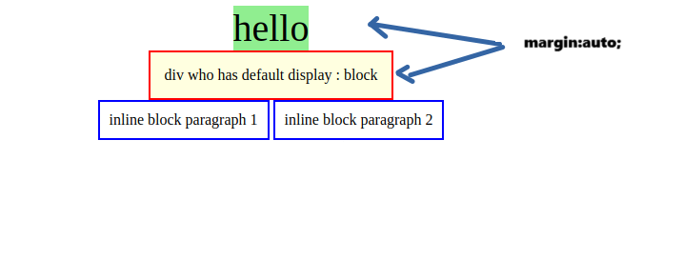

**Q. How to maintain the CSS specifications?**

**ANS:** The specification defines how CSS properties should be implemented by browser vendors, along with detailed algorithms, code samples, and tabular information.

The specifications include the syntax and data types of the language. Detailed explanation of CSS selectors.

The specification also includes:

* The syntax and data types of the language
* Detailed explanation of CSS selectors
* How you can assign values to properties
* The cascade (the "C" in CSS)
* How inheritance works
* The Box Model, etc.

The specification also specifies how stylesheets can be included in your web document and how to target specific media, e.g., print or screen.

The CSS specification prior to CSS3 was a single specification. CSS3, on the other hand, is divided into modules, which are independent specifications that can be worked on by different authors at different paces.

**Q. What are the ways to integrate CSS as a web page?**

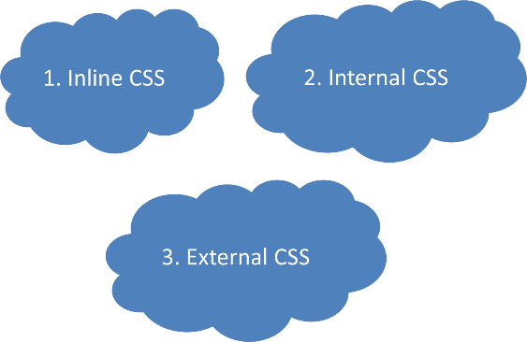 **ANS:** There are three ways to integrate CSS on a web page.

1. ***Inline CSS*** = as the name depicts itself, i.e., in a line. Inline CSS is used within the tag to which we want to apply. Inline CSS is used when we have to apply a specific style to a tag. Inline CSS has the highest priority.

Ex.

**<**[**h1**](https://webplatform.github.io/docs/html/elements/h1)[**style**](https://webplatform.github.io/docs/html/attributes/style)**="[color](https://webplatform.github.io/docs/color" \t "_blank): blue;">This is the INLINE CSS EAXMPLE.</**[**h1**](https://webplatform.github.io/docs/html/elements/h1)**>**

1. ***Internal CSS*** = Internal CSS is used in the same HTML file, but inside the style tag in the head, internal CSS has less priority than inline CSS but is higher than external CSS. In internal CSS, we have to use the selector to refer to the HTML element.

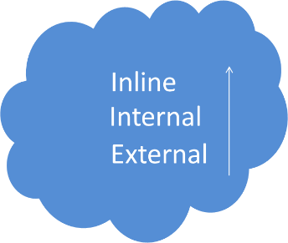

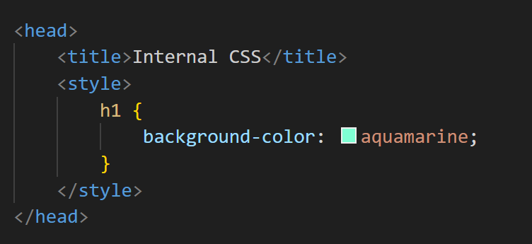

1. ***External CSS***: When we write CSS in the external file and add the link to that file to the HTML file, that is known as external CSS. External CSS is the most preferred way to use CSS in HTML. Using external CSS makes the file load faster, and CSS gets loaded first and then the HTML content gets loaded. Selectors are also used in external CSS to refer to HTML elements. We provide a reference to the CSS file in the HTML file in the head section within the link tag the external file extension is =.css.

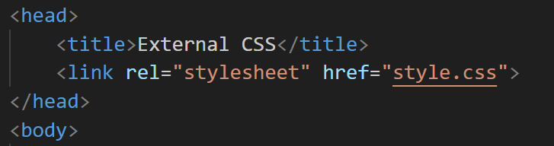

**Q. What are embedded style sheets?**

**ANS: *Embedded Stylesheet***: It allows you to define styles for a particular HTML document as a whole in one place. This is done by embedding the <style> </style> tags containing the CSS properties in the <head> of the HTML document. (Embedded style sheets, also known as internal style CSS.)

* The benefit of embedded style sheets is that they load immediately with the page itself instead of requiring other external files to be loaded. This technique can be beneficial from a download speed and performance perspective.

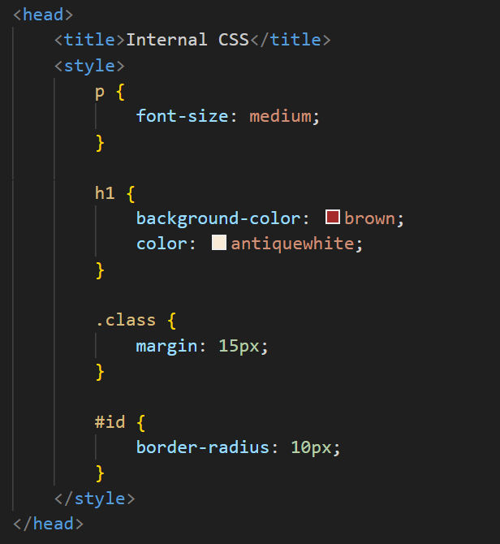

**Q. What are the external style sheets?**

**ANS: *External CSS***: When we write CSS in an external file and add the link to that file to the HTML file, that is known as external CSS. External CSS is the most preferred way to use CSS in HTML. Using external CSS makes the file load faster, and CSS gets loaded first and then the HTML content gets loaded. Selectors are also used in external CSS to refer to HTML elements. We provide a reference to the CSS file in the HTML file in the head section within the link tag.

* The external style sheet can be written in any text editor. The file must not contain any HTML code and must be saved with a .css extension.

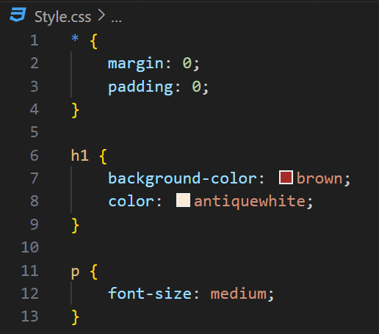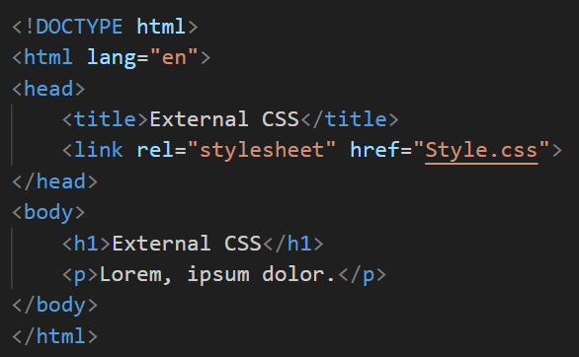

**Q. What are the advantages and disadvantages of using external style sheets?**

**ANS:**

***The Advantages of External-Style Sheets Are as Follows:***

* Using External Style, the styles of multiple documents can be controlled from one file.
* Classes can be created for use on multiple HTML element types in many documents.  
  In complex situations, selector and grouping methods can be used to apply styles.
* Separation of content and presentation: An external style sheet allows you to separate the content of your website (HTML) from the presentation (CSS). This makes it easier to maintain and update your website, as you only need to change the style sheet rather than making changes to the HTML of each individual page.
* Reusable styles: An external style sheet can be reused across multiple pages and websites, saving time and making it easier to maintain a consistent look and feel.
* Improved performance: An external style sheet is only loaded once, even if it is used on multiple pages. This can improve the performance of your website, as the browser does not need to download the same styles repeatedly.
* SEO-friendly − CSS files created externally can be used to control design attributes. In this way, you reduce the quantity of HTML code. One particular advantage is SEO. In other words, search engine spiders won't go through all of those HTML codes. The website's clean code will eventually raise its position in search results.

***The Disadvantages of external style sheets are as follows:***

* While implementing style sheets, we need to test Web pages with multiple browsers in order to check compatibility issues.
* In order to import style information for each document, an extra download is needed.  
  Until the external style sheet is loaded, it may not be possible to render the document.
* CSS, from CSS 1 up to CSS 3, results in confusion among web browsers.
* With CSS, what works with one browser might not always work with another. The web developers need to test for compatibility, running the program across multiple browsers.
* There is a scarcity of security.
* Additional HTTP request: An external style sheet requires an additional HTTP request to load, which can slightly increase the time it takes for the page to render.
* Limited control: With an external style sheet, you have less control over the specific elements on a page, as the styles are applied globally to all elements that use the same class or ID.
* Harder to override: It can be harder to override the styles in an external style sheet, as they are applied globally. To override a style, you need to use more specific selectors or use the “!Important” declaration, which can make your style sheet more complex and difficult to maintain.

**Q. What is the meaning of the CSS selector?**

**ANS:** A CSS selector is the first part of a CSS rule. It is a pattern of elements and other terms that tell the browser which HTML elements should be selected to have the CSS property values inside the rule applied to them.

1. Universal Selector = The asterisk (\*) is the universal selector in CSS. By default, it selects all elements in a document.
2. Element Selector = The element selector selects the HTML element by TAG.

Ex. h1 {

Color: blue;

}

1. Class Selector = "A class selector selects all elements that have a given class name.

For example, .intro would select any element that has a class of “intro” just as .index would select any element that has a class of “index”. The class selector is introduced by (.) A class name should not start with a number.

<h1 class=" intro "> Blue</h1>" **CSS** = . Intro {

color : blue

}

1. 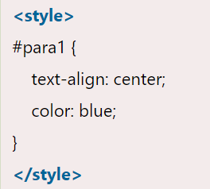ID Selector = The id selector selects the id attribute of an HTML element to select a specific element. An id is always unique within the page, so it is chosen to select a single, unique element.

It is written with the hash character (#).

Let’s take an example with the ID "para1".

<p id="para1">Hello Javatpoint.com</p>

1. Group Selector = The grouping selector is used to select all the elements with the same style definitions.

A grouping selector is used to minimize the code. Commas are used to separate each selector in grouping.

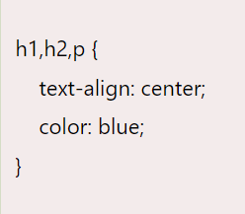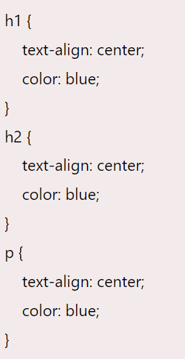

1. [Attribute selectors](https://developer.mozilla.org/en-US/docs/Learn/CSS/Building_blocks/Selectors#attribute_selectors) = This group of selectors gives you different ways to select elements based on the presence of a certain attribute on an element.

<a href="http://hubspot.com">hubspot.com</a>

CSS = A [href = hubspot] {color:orange;}

1. [Pseudo-classes and pseudo-elements](https://developer.mozilla.org/en-US/docs/Learn/CSS/Building_blocks/Selectors#pseudo-classes_and_pseudo-elements) = This group of selectors includes pseudo-classes, which style certain states of an element. The :hover pseudo-class for example selects an element only when it is being hovered over by the mouse pointer.
2. 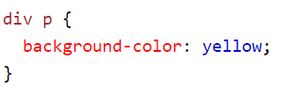Descendant Selector = The descendant selector matches all elements that are descendants of a specified element.

The following example selects all <p> elements inside <div> elements.

1. 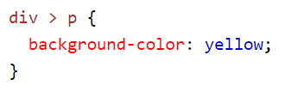Child Selector (>) = The child selector selects all elements that are the children of a specified element.

The following example selects all <p> elements that are children of a <div> element:

**Q. What are the media types allowed by CSS?**

**ANS:** Media queries in CSS3 extended the CSS2 media types idea: instead of looking for a type of device, they look at the capability of the device.

* Media queries can be used to check many things, such as:
* Width and height of the viewport
* Width and height of the device
* Orientation (is the tablet or phone in landscape or portrait mode?)
* Resolution
* Using media queries is a popular technique for delivering a tailored style sheet to desktops, laptops, tablets, and mobile phones (such as iPhones and Android phones).
* *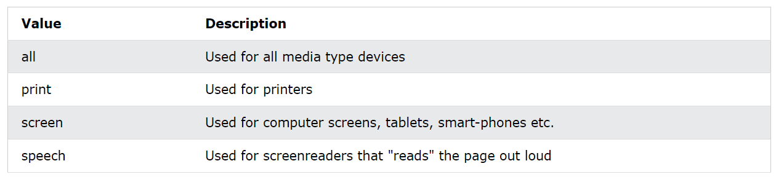*In addition to media types, there are also media features. Media features provide more specific details to media queries by allowing users to test for a specific feature of the user agent or display device. For example, you can apply styles to only those screens that are greater or smaller than a certain width.

**Q. What is the rule set?**

**ANS: *RULE SET-*** A table of instructions is used by a controlled interface to determine what data is allowable and how the data is handled between interconnected systems.

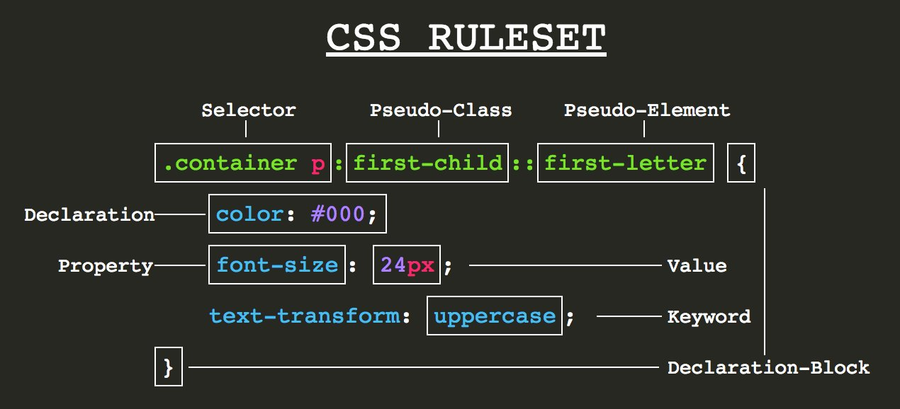

* The complete declaration is a rule set.
* The .container is a selector. The selector is of 2 types, namely, the id selector, denoted by a hash(#), used to apply the property having the unique id. The second is a class selector denoted by a dot(.), used to select all elements that belong to a particular class attribute.
* The key/value pair, which is separated by a colon in between and ends with a semi-colon, is a declaration.
* The key is property name, and the value is property value; both the key and values are case-insensitive by default in CSS.
* The portion in which the curly braces and the properties are declared is the declaration block.

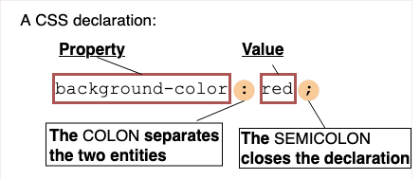

**Q. Create Layouts**

**ANS:** [**https://github.com/kbu09/Module-CSS-and-CSS-3-task/tree/main/CSS%203**](https://github.com/kbu09/Module-CSS-and-CSS-3-task/tree/main/CSS%203)

**Pending Questions from Assignments – 1**

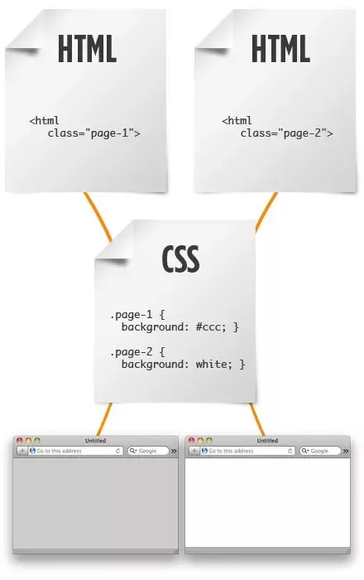**Q. What is the ‘class’ attribute in HTML?**

**ANS:** The class [global attribute](https://developer.mozilla.org/en-US/docs/Web/HTML/Global_attributes) is a space-separated list of the case-sensitive classes of the element. Classes allow CSS and JavaScript to select and access specific elements via class[selectors](https://developer.mozilla.org/en-US/docs/Web/CSS/Class_selectors) or functions like the DOM method.

* The class attribute is part of the [global](https://www.w3schools.com/tags/ref_standardattributes.asp) attributes and can be used on any HTML element multiple times.
* The class attribute specifies one or more class names for an element. The class attribute is mostly used to point to a class in a style sheet.
* In HTML, the "class" selector is used to select an element with a specific class attribute. The class selector starts with a period (.) followed by a class name. Unlike the id selector, we can attach multiple selector to an HTML element. Therefore, the class can be applied many times within a page. The important point to note about the class selector is that the class name must not be started with a number.

**Q. What is the difference between the ‘id’ attribute and the ‘class’ attribute of HTML elements?**

|  |  |  |
| --- | --- | --- |
| KEY | ID | CLASS |
| Syntax | In HTML, for an element, the ID name starts with the "#" symbol followed by a unique name assigned to it. | "Class" assigned to an element has its name starts with "." followed by class name. |
| Selector | Only one ID selector can be attached to an element. | Multiple class selectors can be attached to an element. |
| Uniqueness | ID is unique in a page and can only apply to at most one element | The class can be applied to multiple elements so it could be multiple times on a single page. |

**ANS:**

**Q. How are active links different from normal links?**

**ANS:** Normal links are links which are there on the page and have not been clicked yet. Active links are those links, which have just been clicked at that instant.

**Normal Links**

* In HTML, an unvisited link is a hyperlink that is not yet clicked by the user. By default, the Normal links will be in blue in color with an underline. However, we can customize the style using the CSS properties (a:link).

**Active Links**

* An Active link is a hyperlink that is currently being interacted with the user. Whenever the user holds the mouse button on the link and not released yet or if right clicked on it, it will change its color into red, this is when the link will be in active state.
* The active state is temporary and ends once the user releases the mouse button. However, we can customize the style of the active links using the CSS properties (a:active).